(Reworn-revival)

Synopsis Submitted to

D Y Patil International University, Akurdi, Pune

in partial fulfillment of the degree of BCA.

BCA (Bachelor of Computer Applications)

(Cloud and Information Security (CIS))

Submitted By:

Gunjan Rajgire- 20210801091

Devyani Bhosale- 20210801064

Sakshi Kalaskar- 20210801028

Under the Guidance of

MS. Shobhana Patil Signature:

School of Computer Science Engineering & Applications

D Y Patil International University, Akurdi, Pune, INDIA, 411044

[Batch 2021]

**CONTENTS**

**CHAPTER PAGE NO.**

1. INTRODUCTION
2. REVIEW OF LITERATURE
3. PROPOSED METHODOLOGY AND FRAMEWORK DESIGN
4. PREPARING PROJECT PLAN
   * PERT/GANTT Chart
5. REFERENCES

**Chapter 1:INTRODUCTION**

 A Reworn revival is simple clothing rental web application allows users to browse available clothing items, rent them for a certain period, and return them. The application should have user authentication, item listing, rental management, Search Functionality and User Profile Management.

**BACKGROUND**

A clothing application is a software program or platform that enables users rent their clothing according to their need . It will work on web applications. clothing rental web application using React, Next.js, and MongoDB can be designed to provide a seamless user experience for renting clothing items online.

Social Media Integration: Allow users to share their rented clothing items on social media platforms like Facebook, Instagram, and Twitter. This can help increase brand awareness and user engagement.

By integrating this types services, a clothing rental web application can provide a more comprehensive and user-friendly experience, increasing user engagement, satisfaction, and overall business growth.

Here are some key functions related to a clothing rental web application :

* User Registration and Login
* Clothing Item Listing
* Clothing Item Details
* Shopping Cart
* Rental Management
* User Profile Management
* Search Functionality

**PROBLEMS & GAP IDENTIFICATION**

Problem & Gap Identification:

Authentication: The system uses JWT tokens for authentication. Users can register and log in using their email and password. The system stores user information securely in the MongoDB database.

Authorization: The system implements role-based access control (RBAC) to manage user permissions. Admins can manage all users, while customers can only manage their own rental history.

User interface: The user interface is responsive and built using React and Next.js. Users can browse available clothes, add them to their rental cart, and check out.

User Management: The system stores user information, such as name, email, and phone number, in the MongoDB database.

Rental History: The system stores and displays the rental history of each user.

Cloth Management: The system allows admins to add, edit, and delete clothes. It stores information about available clothes, such as name, description, price, and image URL, in the MongoDB database.

Search: The system implements a search functionality that allows users to search for clothes based on keywords or filters.

API: The system uses a RESTful API using next to handle communication between the frontend and the backend.

Database: The system stores all data in a MongoDB database. Collections include users, clothes, and rental history.

**CHAPTER 2: REVIEW OF LITERATURE:**

A review of literature on cloth rental applications provides insight into the evolution, functionalities, usage patterns, and impacts of various cloth rental platforms. Here's a structured overview:

**History Evolution:**

•The first cloth rental systems were manual, with customers visiting physical stores to browse and rent clothes. •The rise of e-commerce platforms like Amazon and eBay in the late 1990s and early 2000s revolutionized online shopping and introduced the concept of online cloth rental.

**Functionalities:**

Core features include browsing and searching for clothes, adding items to a rental cart, and completing the rental process.

**User behavior and social impact:**

Cloth rental platforms have transformed the fashion industry, enabling users to rent clothes instead of purchasing them, reducing waste and promoting sustainability. •They have also facilitated the rise of influencer-driven fashion, where celebrities and influencers promote rental platforms and their products.

**Privacy and security concerns:**

Privacy issues, data breaches, and concerns over data ownership and surveillance have plagued some cloth rental platforms. End-to-end encryption.

**Future trends and challenges:**

The convergence of cloth rental platforms with artificial intelligence (AI) and machine learning is expected to enhance user experiences through features like personalized recommendations and improved search functionality. •Challenges include addressing misinformation and fake news dissemination, ensuring inclusivity and accessibility, and navigating regulatory complexities, particularly regarding data privacy and security.

**C****HAPTER 3: PROPOSED METHODOLOGY AND FRAMEWORK DESIGN**

• Easy to use GUI (Graphical User Interface), hence any user with minimal knowledge of operating a system can use the software.

• Platform independence: The application operates on any system irrelevant of the underlying operating system.

• Unlimited clients: “N” number of users can access the web application .

Designing the framework for a cloth rental application involves structuring the software components and defining how they interact with each other.

* **Client-side Framework:**

**User Interface (UI) Layer:**

Improved UI design for a more intuitive and visually appealing user experience.

Responsive design for seamless browsing and interaction on various devices.

**Cloth Web Interface Components:**

* Improved product listing page with advanced search filters, sorting options, and pagination.
* Improved product detail page with detailed product information, images, and videos.
* Improved rental process with secure payment options and clear checkout steps.
* Improved wishlist functionality with the option to save and share products.
* Improved user profile page with personalized information, preferences, and order history.
* Improved user authentication and authorization system with secure login and registration options.
* Improved user-generated content management system with moderation tools and options for featured content.

**Data Management Layer:**

**Server-side Framework:**

* **State Management:**
* Improved state management system for efficient data handling and synchronization.
* Advanced caching mechanisms for faster data retrieval and rendering.
* **Data Storage and Retrieval:**
* Improved data storage and retrieval options for efficient data management and processing.
* Advanced indexing and querying mechanisms for faster data retrieval.

**Business Logic:**

* **User Authentication:**
  + Handles user registration, login, and logout processes.
  + Manages user sessions and access control.
* **Data Handling:**
  + Processes incoming data .
  + Validates the permissions.

**Data Access Layer:**

* **Database (e.g., MongoDB,ExpressJS,NodeJS,React):**
  + Stores user profiles, item List , user records , etc.
  + Supports efficient querying and indexing for fast retrieval of data.
  + User Registration: Users need to create accounts by providing necessary information such as name, email address, and password. Optionally, you might include additional fields or use alternative authentication methods like social media sign-in.
  + Password Hashing: When users register or change their passwords, the passwords should be securely hashed and stored in the database. Hashing ensures that even if the database is compromised, passwords are not easily retrievable.
  + Login: Users provide their credentials (usually username/email and password) to authenticate themselves. The server verifies the credentials against the stored information in the database.
  + Session Management: Upon successful authentication, the server creates a session for the user. This session is often represented by a unique session ID stored as a cookie or in local storage on the user's device.
  + Authorization: After authentication, the server determines what actions the user is allowed to perform. For example, in a cloth rental system, users may be authorized to rent clothes, view their rental history, or perform administrative tasks.
  + Token-based Authentication (Optional): Instead of using sessions, you might implement token-based authentication using JSON Web Tokens (JWT). With JWT, a token containing user information and a signature is issued upon successful login. This token is then included in subsequent requests to authenticate the user.
  + HTTPS: Ensure that all communication between the client and server is encrypted using HTTPS to prevent eavesdropping and man-in-the-middle attacks.
  + Security Measures: Implement additional security measures such as rate limiting, CAPTCHA, and account lockout to prevent brute force attacks and other malicious activities.
  + Logout: Provide users with the ability to log out, which invalidates their session or token and prevents unauthorized access to their account.
  + Remember Me Functionality (Optional): Offer users the option to stay logged in across sessions using long-lived tokens or cookies. This feature should be implemented securely to prevent unauthorized access.
  + Password Reset: Allow users to reset their passwords in case they forget them. This typically involves sending a password reset link to the user's email address or using other verification methods.
  + Two-Factor Authentication (Optional): Implement two-factor authentication (2FA) to enhance security by requiring users to provide an additional form of verification, such as a code sent to their phone or a hardware token.
  + User Verification: Verify users' identities by requiring them to provide additional information, such as a government-issued ID or a credit card, to confirm their identity.
  + Role-Based Access Control: Implement role-based access control (RBAC) to manage user permissions and access levels within the system**.**

**CHAPTER 4: PROJECT PLAN**

* Planning Phase:
  + Conduct market research analyse, existing cloth Rental applications, identified their strengths and weaknesses, and gather user feedback to understand user preferences and pain points.
  + Establish project timeline and milestones, break down the development process into manageable phases and set deadlines for each milestone.
* Requirements Gathering:
  + Identify key features and define the essential features of the cloth web application
* Design Phase:
  + Define the visual elements, color scheme, typography and branding elements to create a cohesive and visually appealing UI design.

* Development Phase:
  + Configure development tools, version control systems, and project management platforms for efficient collaboration among team members.
* Testing Phase:
  + Test the application's features and functionalities to ensure they meet the specified requirements and work as expected.
* Deployment Phase:
  + Deploy the application to the chosen hosting environment, ensuring proper configuration, scalability, and monitoring.
* Maintenance Phase:
  + Monitor server logs, error reports, and user feedback to identify and address performance issues, downtime, and scalability concerns.

Overview Of Project :

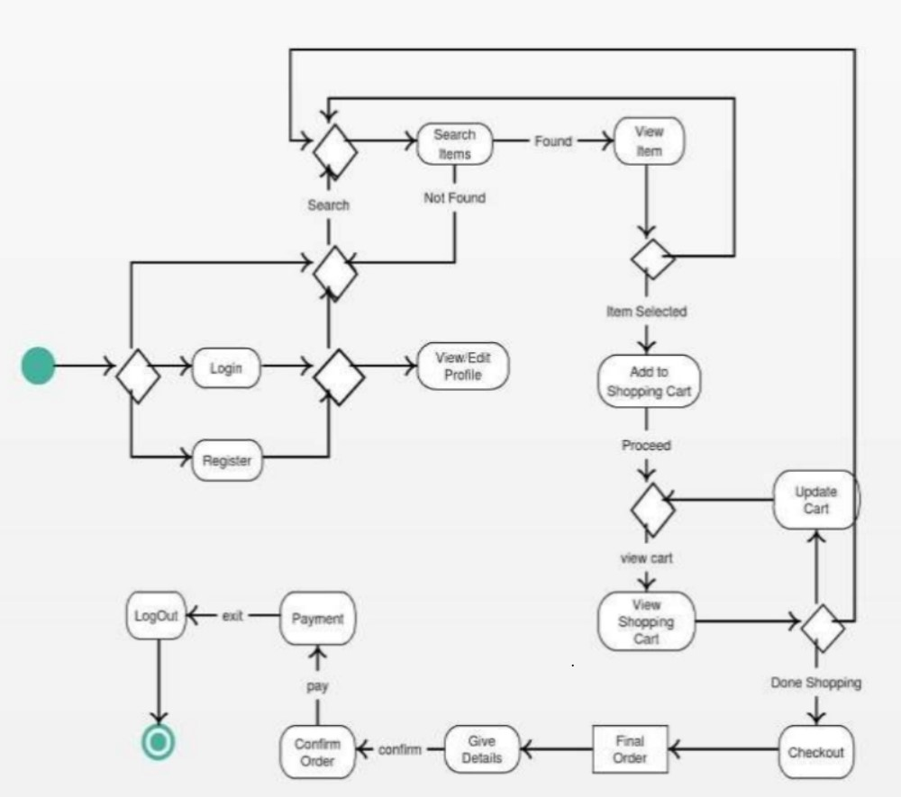

**CHAPTER 5: REFERENCES**

1. Wang Wei, Zhou Yi. Chemical Fiber & Textile Technology,2016,45(04):27-31. (in Chinese)

2. Li Rong, Fan Ziling. Research on Problems and Countermeasures of Clothing Sharing in Sharing Economy [J]. Journal of Taiyuan City Vocational and Technical

College,2018(05):38-39.

3.Wang Bei, Zhou Yang, Si Xingyu, Zhang Shangyan, He Lingyue. Research on the development status and development strategy of apparel rental platform in China [J]. Light Textile Industry & Technology,2020,49(05):72-74.

1. Jia Wen. Research on the Influence and Trend of New Retail Business Model on the Change of Clothing Market Consumption [J].Liaoning Economy,2019(07):48-50.
2. Li Shuai, Zhu Yingjie. Exploring the business model of renter under the sharing economy [J]. Think Tank Times,2017(09):68+246.
3. National Information Center. China Sharing Economy Development Report (2021) [R]. Sharing Economy Research Center.2021-2-19.

7. Zhao Na. Sharing Economy Attack: Can Online Clothing Renting Bring Closet Revolution [J]. Decision Exploration (First Half),2017(03):42-43.